Exp No.7: Analog Beamforming Analysis Using MATLAB

AIM: To analyze the performance of analog beamforming by studying beamforming gain, beam width, and main lobe direction using MATLAB.

Objective 1: To analyze the beamforming gain achieved by varying the number of antenna elements in an analog beamforming system using MATLAB.

Program :

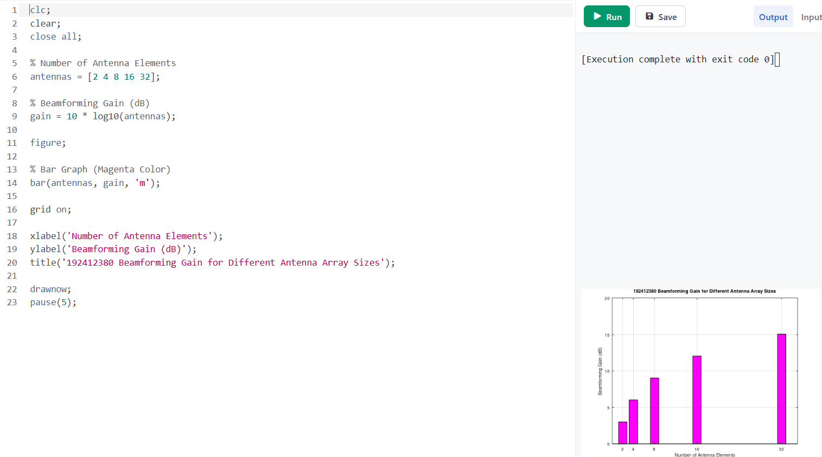

OUTPUT :
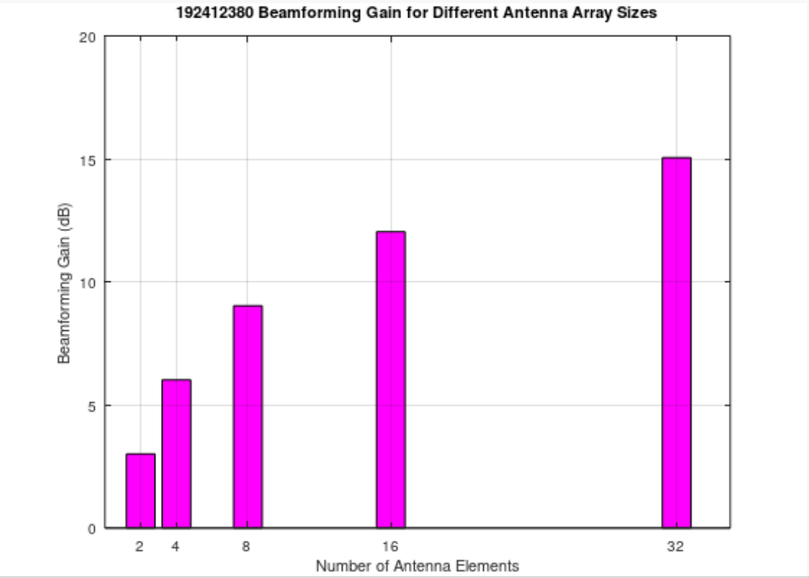

Objective 2: To compare the beam width of an antenna array for different beamforming configurations using MATLAB.

Program
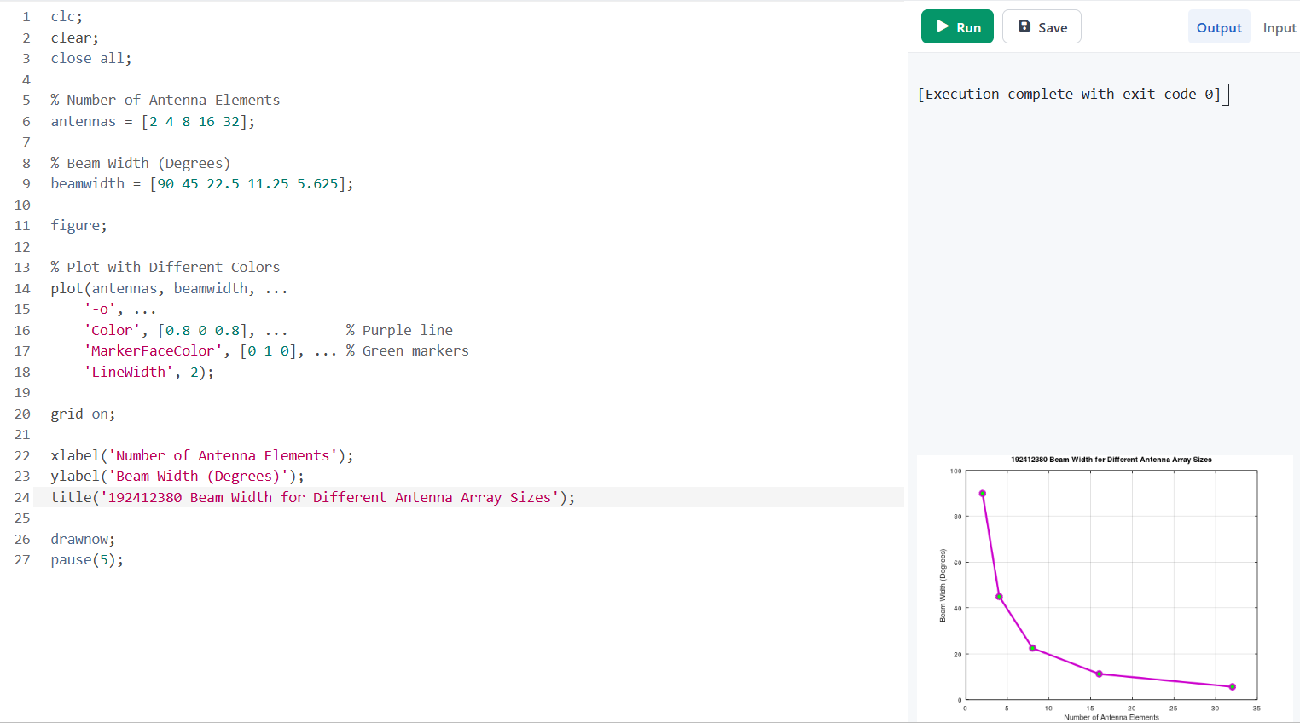
OUTPUT :
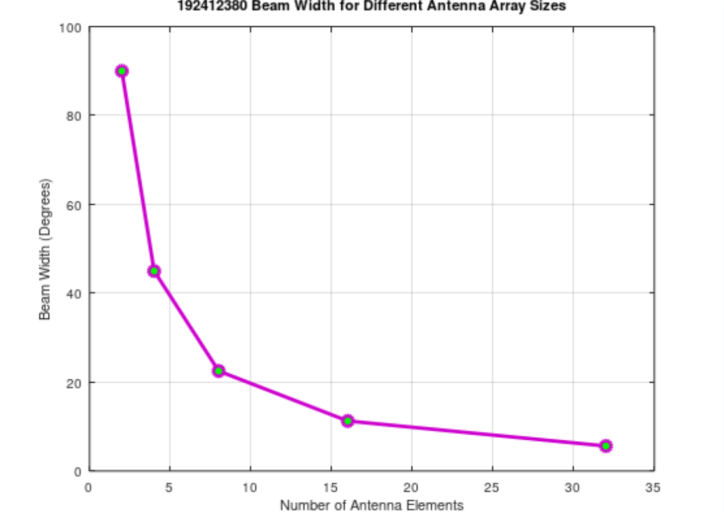
Objective 3: To analyze the main lobe direction by steering the antenna array beam to different angles using MATLAB.

program
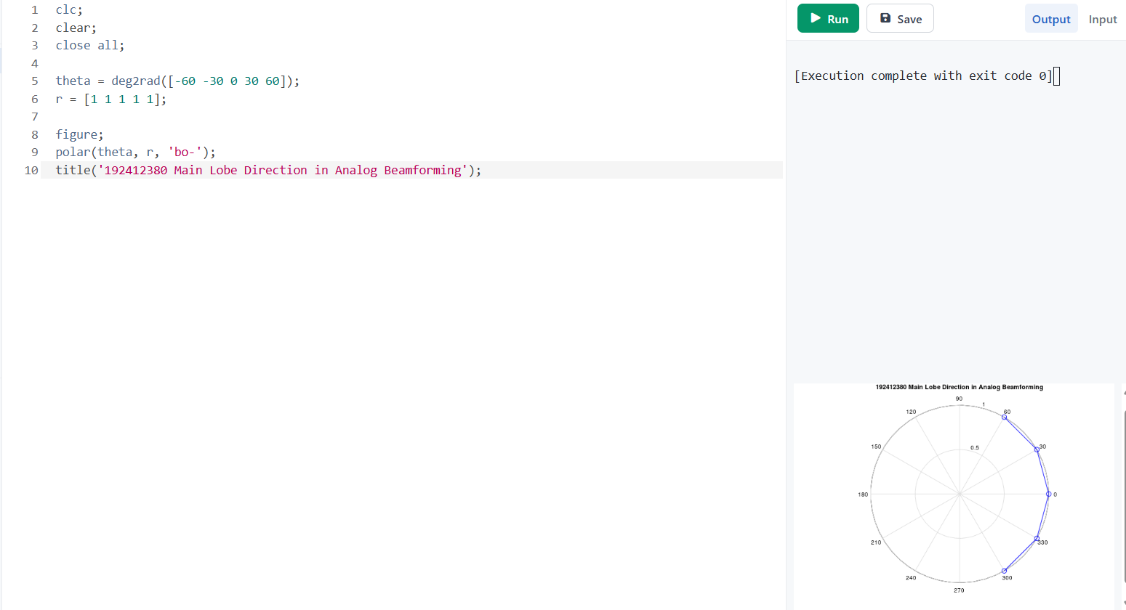

OUTPUT :
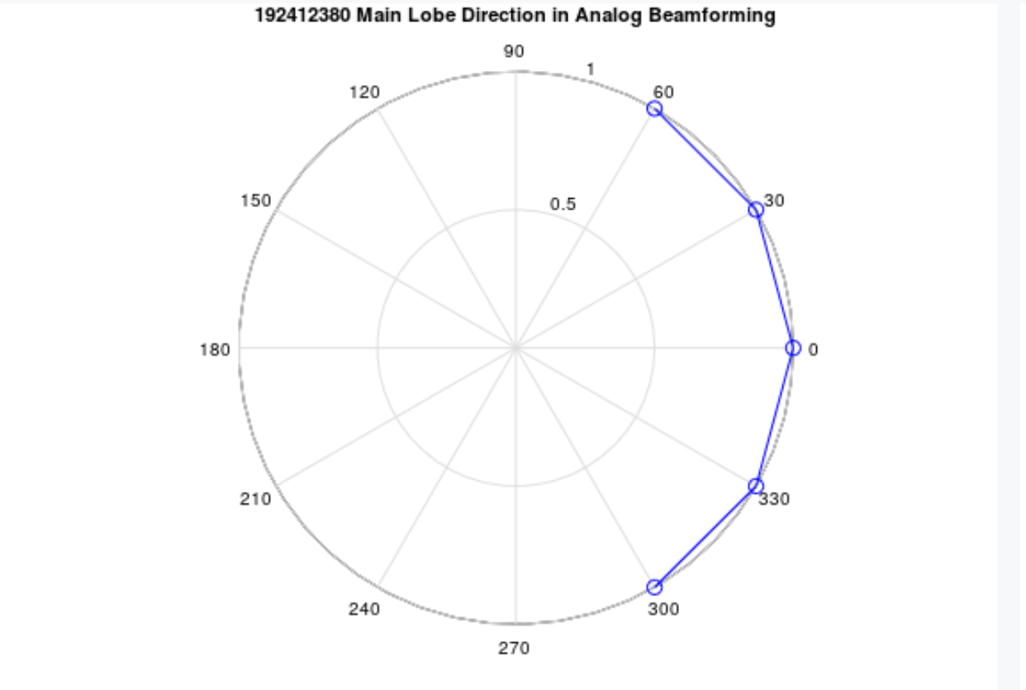
Result:
The MATLAB analysis successfully demonstrated the characteristics of analog beamforming. The results showed that increasing the number of antenna elements improves beamforming gain and reduces beam width, while phase adjustment enables the main lobe to be steered toward different directions.

Practical Questions
A wireless communication system employs analog beamforming to improve signal strength and coverage by directing the transmitted beam toward a desired user location using antenna arrays. By adjusting the phase of antenna elements, the beam can be steered, and key performance parameters such as beamforming gain, beam width, and main lobe direction can be analyzed. Using MATLAB, simulate an analog beamforming system and analyze its performance.
- To analyze the beamforming gain achieved in an analog beamforming system by varying the number of antenna elements and observe its effect on signal strength.
- To compare the beam width of an antenna array for different antenna configurations and study how beam width changes with increasing antenna elements.
- To analyze the main lobe direction of the antenna array by steering the beam toward different angles using phase adjustments in an analog beamforming system.

